Richmond Fellowship - Kirklees Employment Service
Annual Report 2016 – 2017
Introduction
Kirklees Employment Service is a specialist employment service designed to offer employment support to people with mental health issues and also individuals with autistic spectrum conditions and early onset dementia. Kirklees Employment Service aims to match individuals to the type of work and workplace in which they can succeed.

The people who use our services are central to everything we do. We believe that each person is unique, and should have the opportunity to take control over his or her life, and to develop new meanings and purposes. We concentrate on the person and his or her personal needs, choices and aspirations, rather than on diagnostic categories or labels.

Some of the benefits people experience from getting back into work or education;
- Making new friends, developing a sense of identity
- Keeping busy and establishing a routine
- Getting involved in the local community and feeling useful
- A sense of achievement
- Learning new skills
- Gaining confidence

“I have gained employment as a Support Worker at a local charity. My involvement with Richmond Fellowship has been a positive experience and provided me with the confidence to follow my dream of working in the social care sector, thankyou”.

Kirklees Employment Service

Supports people to return to paid employment, voluntary work, work placements or further education. We offer information, advice and guidance in one to one sessions with Employment Advisors, and we deliver a range of group based learning opportunities.

Our aim is to encourage each individual’s sense of independence, purpose and fulfilment, and develop the skills necessary to manage their mental health problems and return to work or training. Our fully flexible range of work-related support enables individuals to join the workforce for the first time, re-join after a period of absence, retrain in the career of their choice or retain their current position with retention support.

General developments
In the last year, we were successful in retaining our contract for another three years until 2020. Also we have moved our Dewsbury service and we are now sharing space with Connect Housing in Bond Street in central Dewsbury. This is a lovely building that has been fully refurbished and modernised and it is fully accessible to people with disabilities.
Our Wellbeing room has also moved to Connect Housing; this can provide a relaxing, low stimulus space and accessible computer equipment for people on the Autism Spectrum.
Staff training this year has included; Suicide Intervention, Cognitive Behavioural Therapy and Legal Highs, and also, two Employment Advisers successfully completed their QCF Level 4 qualifications in Information, Advice and Guidance. Also, four Employment Advisers successfully completed a Level 3 Certificate in Education and Training.

“It’s always been a safe place/environment to come for support/training. Really positive attitude to diversity. Lots of practical help with IT and application forms etc.”

Richmond supported me to find voluntary work, which helps both myself and the community and it’s very unlikely that I would have achieved this without their help. This has boosted my morale and general wellbeing and given me a better quality of life.

“I’m really grateful for the support I have received from Richmond Fellowship. Working with my Employment Adviser has enabled me to come on in leaps and bounds, thankyou.”

Peer Support

The Peer Support element has grown significantly in the last year. One of the key aspects of the service is volunteers and this year saw a huge rise in the number of volunteers from 3 (March 2016) to 14 (March 2017). The volunteers have been involved in co-designing, co-producing and co-facilitating the wide range of courses, workshops and activities that we have provided including our befriending service.
Due to the increase in volunteer numbers we have been able to create a brand new course (Ways to Wellbeing), a brand new support group (Kirklees Hearing Voices Group – co-produced with Touchstone, Connect, Samaritans, Pathways & Recovery College) and to improve the attendance and running of the existing groups and courses such as the Art & Craft group and the Newsletter Group. In addition to this the Confidence to Work course experienced continued success and we were able to get the course placed in the Recovery College prospectus.
Another major success of the Peer Support Service has been in the training that is now being presented. We now offer a Level 2 (Open College Network) Accredited Volunteer Training Course to all of our volunteers. This has meant that so far 9 volunteers have achieved the qualification and by August 2017 all 14 of our volunteers should have it. This was an important step as it ensures that all our volunteers can progress to bigger and better things and gives them a great deal of evidence to present regarding the amazing role that they accomplish with us.
Overall 2016-2017 saw 173 Peer supported activities provided with 602 attendances and 178 new individuals accessing Peer Support.

Outcomes
For many people, joining Richmond Fellowship is the first step back on the road to employment related activity. Our skilled and friendly Employment Advisers support clients to identify what they want to achieve and then provide advice and guidance on how to reach their goals.
Employment Advisers are well linked in to wide networks of partner organisations, which enables them to obtain useful information about local vacancies, voluntary work or learning opportunities.
At Richmond Fellowship, we treat people as individuals, listening to their concerns, helping them to identify their strengths and re-learn problem solving skills. The opportunities we seek out are determined completely by the needs and wants of the people we work with.

Service User outcomes for this financial year consist of:

- 119 Self Improvement Courses.

Some of the self improvement course clients have attended;
A Terrarium workshop, Eco Book-Binding course, coffee morning, RF Confidence to Work course, Job Centre Breakfast event and the Great Outdoors Project.
These informal opportunities enable people to make new friends and gain confidence, have fun and develop or re-discover skills.

Overall I have been very satisfied with the service, for example, attending the Confidence to Work Course and help getting into the DIP training at Batley, and I achieved Level 2 certificates in Maths and English and Level 1 in Information Technology.

- 62 Accredited Courses.

Many people want to return to education, either to develop their confidence or to enable a return to work. An example of how we support this might be going through a college prospectus with someone, or exploring opportunities for childcare.

Examples of the courses successfully completed this year are; LAB Project, Mental Health course with Sheffield University, Criminology Degree and a Level 2 RF Volunteering course.

- 29 Work Placements.

We take care to match people with opportunities that match their experience, skills and hopes and we educate employers about mental health issues. We ensure that all placements set up are safe and that people are not exploited, and we meet with employers and clients regularly during the 12 week placement to review progress and iron out any problems.

This year’s Work Placements included; Warehouse Operative, Retail Assistant plus Activities Helper and also Mini Bus Driver both working with older people. We are very grateful to the many caring, supportive employers who make this possible.

Referrer Feedback;
“Thankyou so much for your support. My client was very happy with your help. I was very impressed by your work and professionalism. My client is now in work due to your help and has been for the last three months, he has passed his probation period and now holds a permanent job thanks to your dedication.

Out and about
Some of the creative activities of staff and service users;

LEFT: Example of decoupaged craftwork created by RF clients in the Art & Craft Group

RIGHT: A photograph taken by an RF client that was displayed in the Spring Newsletter, produced by the Newsletter Group.

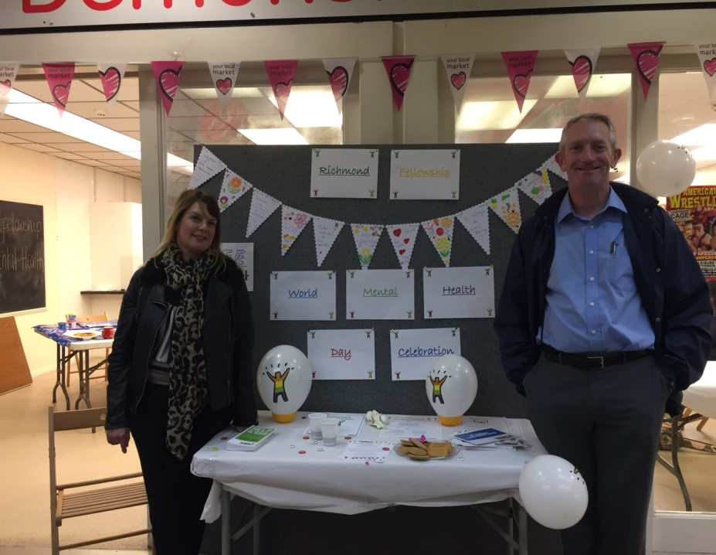

Photograph by Tina Bridgewater

LEFT: Alison Walker (Employment Advisor) and Paul moulding (Team Leader) outside our room at Queensgate Market to promote World Mental Health Day 07.10.16

- 68 Volunteering Opportunities.

Volunteering is a great way to help others whilst helping yourself.

Volunteering helps people recover their confidence as part of their recovery journey and can give many benefits;
- Trying out a different job role
- finding out about paid work opportunities
- making friends
- feeling like you are making a positive contribution
- fun
- Improved health
- trying something new
- learning something new
- boosting CV with recent experience
- better employability
This year we have supported people into a range of different voluntary roles, which included; Activity Worker (with older people), charity driver, helping children to read, social group facilitator and Support Worker.
Comments from our Confidence to Work course;

Useful links to websites and structuring examples in interviews, looking at positives from mental health condition, focussing on strengths I have gained.
Learnt new things about the law.
Discussing and hearing different opinions.
The chance to join in and speak.
I could express myself.
An educational 2 hours, well presented, good communication between tutors and attendees.
Interactive group activity and practical strategies for reducing anxiety.
Taught me relaxation techniques.
Friendly, informative; enjoyed covering letter.
Everything was excellent, keep it up; friendly and informative.
Being able to talk about the things that can be difficult when job searching.
Disclosing mental health to prospective employer.
Creating a recovery CV really helped me to view things more positively.
Tutor showed confidence and ability to give attendees confidence in finding work.

- 57 Paid Work Opportunities.

This year, we supported people into paid work in the following roles; Cleaner, Receptionist, Sales Assistant, Radio Disc Jockey, Specialist Support Worker, Warehouse Operative, Accounts Support Officer, Bagel Artist, and many more.

Supporting someone into employment can include helping them to create a CV, learning how to use Universal Jobmatch, setting up a Hotmail account, doing a practice interview, and more.

The team also contacted 245 employers to discuss employment, placement and voluntary opportunities.

In addition to helping people find work, we also helped eight people last year to move from one job to a more satisfying role or to get more hours. By enabling people to be happier in their work, this enables people to have better mental health, because a great deal of stress is caused by people being in jobs they dislike.

- 65 people supported to Retain their job.

We support people to retain their employment, whether in their current role, for example through returning to work after sickness absence, or with a new employer.

Retention support includes:

- Return to work plans
- Disclosing a mental health problem
- What to do about bullying and harassment
- How to achieve a work-life balance
- Managing a mental health problem at work
- Help with looking for a new job
- One-to-one consultation
- Sign posting for legal advice if appropriate
- Liaison with employers, Union representatives and Occupational Health departments

For example, a lady was struggling at work due to her mental health and this had caused conflict in the workplace which had resulted in her employer starting disciplinary proceedings against her. One of our Employment Advisers arranged for the disciplinary meeting to be postponed to allow time for her to support this lady to write a statement. The adviser accompanied her to the hearing and also raised concerns about how the lady had been treated. The outcome was that she was not sacked, which had been looking likely, and that the employer sought legal advice to ensure that they would be able to comply with the Equalities Act in the future.

Annual Statistics
Year | Total Referrals Received | Paid work | Voluntary Work | Accredited Courses | Self Improvement Courses | Work Placement | Retention | Total
2012-13 | 79 | 13 | 26 | 34 | 37 | 15 | 11 | 136
2013-14 | 141 | 46 | 27 | 48 | 67 | 31 | 26 | 245
2014-15 | 248 | 52 | 55 | 55 | 125 | 30 | 48 | 365
2015-16 | 189 | 46 | 68 | 68 | 91 | 15 | 39 | 327
2016-17 | 240 | 57 | 68 | 62 | 119 | 29 | 65 | 400

Comparison to previous years;

Finance
Expenditure at a glance

Expenditure detail
TOTAL INCOME | 271,243
Employment Costs | 176,921
Other Employment Costs | 11,439
Direct Property Costs (Rent & Insurance) | 17,223
Service Management | 9,640
Training Costs | 5,436
Other Staff & Internal Events | 576
Administrative Costs | 13,893
PR, Marketing & Ext. Events | 124
Equipment & Vehicle Costs | 334
Prof. / Fin. & Governance | 922
IT Costs | 7,331
Asset Costs | 3,493
Personal & Care Costs (SU Costs) | 316
Overheads | 40,896
TOTAL EXPENDITURE | 288,547
SURPLUS/(DEFICIT) | -17,305

Vision and targets for next year

This year we have already revised our staffing structure to enable us to hit more stretching targets; this has resulted in new staff being recruited. These changes will take some time to bed in, and also to further support this, we will be providing training for staff on working with employers.

Our waiting list, which was very high, has now come down, and we plan this year to develop closer links with local mental health services to generate referrals.

We also need to reach out to generate more referrals from the Asian community and from women in general. This will involve the team in marketing and outreach activities, working in partnership with community organisations.

In addition, we plan to market our retention service to employers as we want to generate more referrals of people needing retention support.

Currently, we are involved in trialling a new type of web based service, this will be available to people that use our service later in the year, and will enable them to make a self referral to the service online, and also to update their action plan from home. The aim of this is to enhance, not replace, the existing service, and use of the new facility will be voluntary for those that want it.

Lastly, we plan to hold a consultation event with people who use our service to find out what ideas they have for how we can continue to develop and improve in the future.

