The Five
Values Report
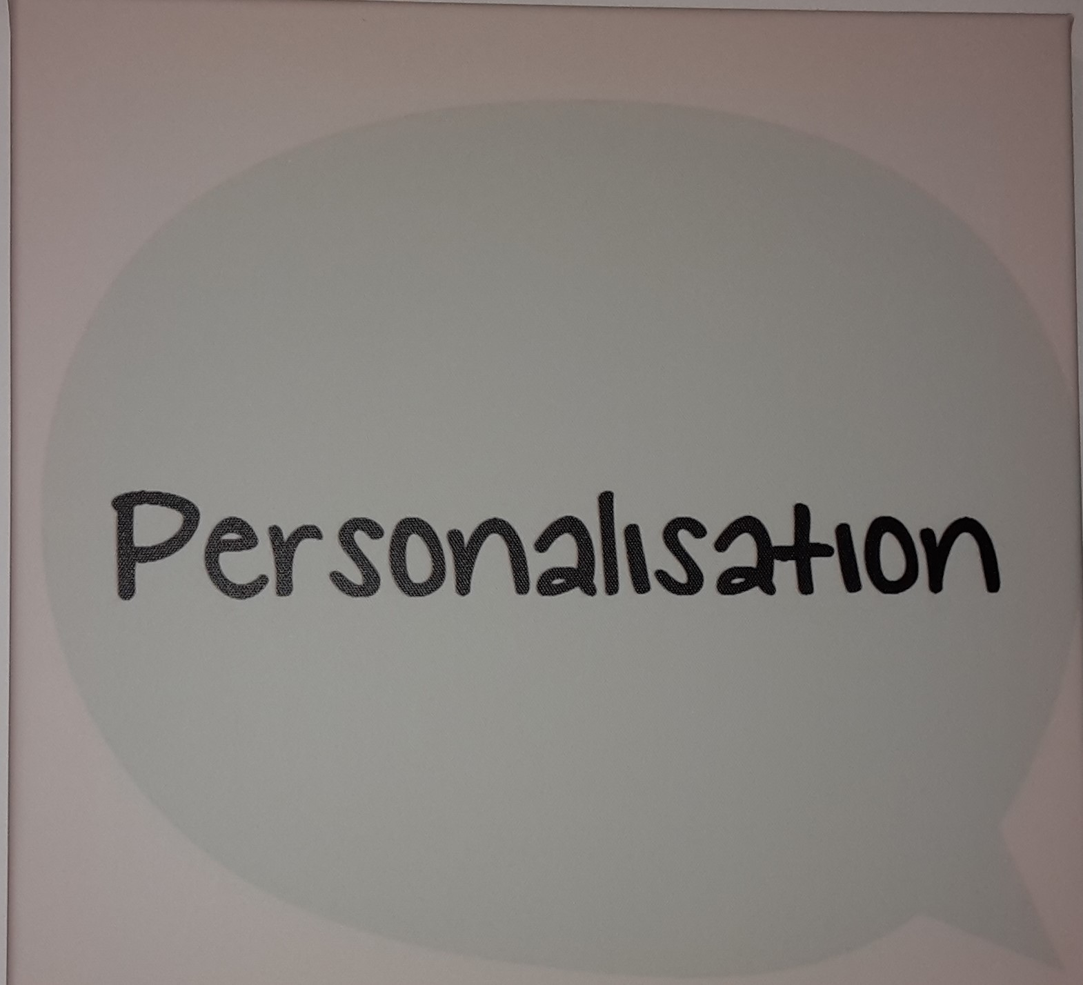
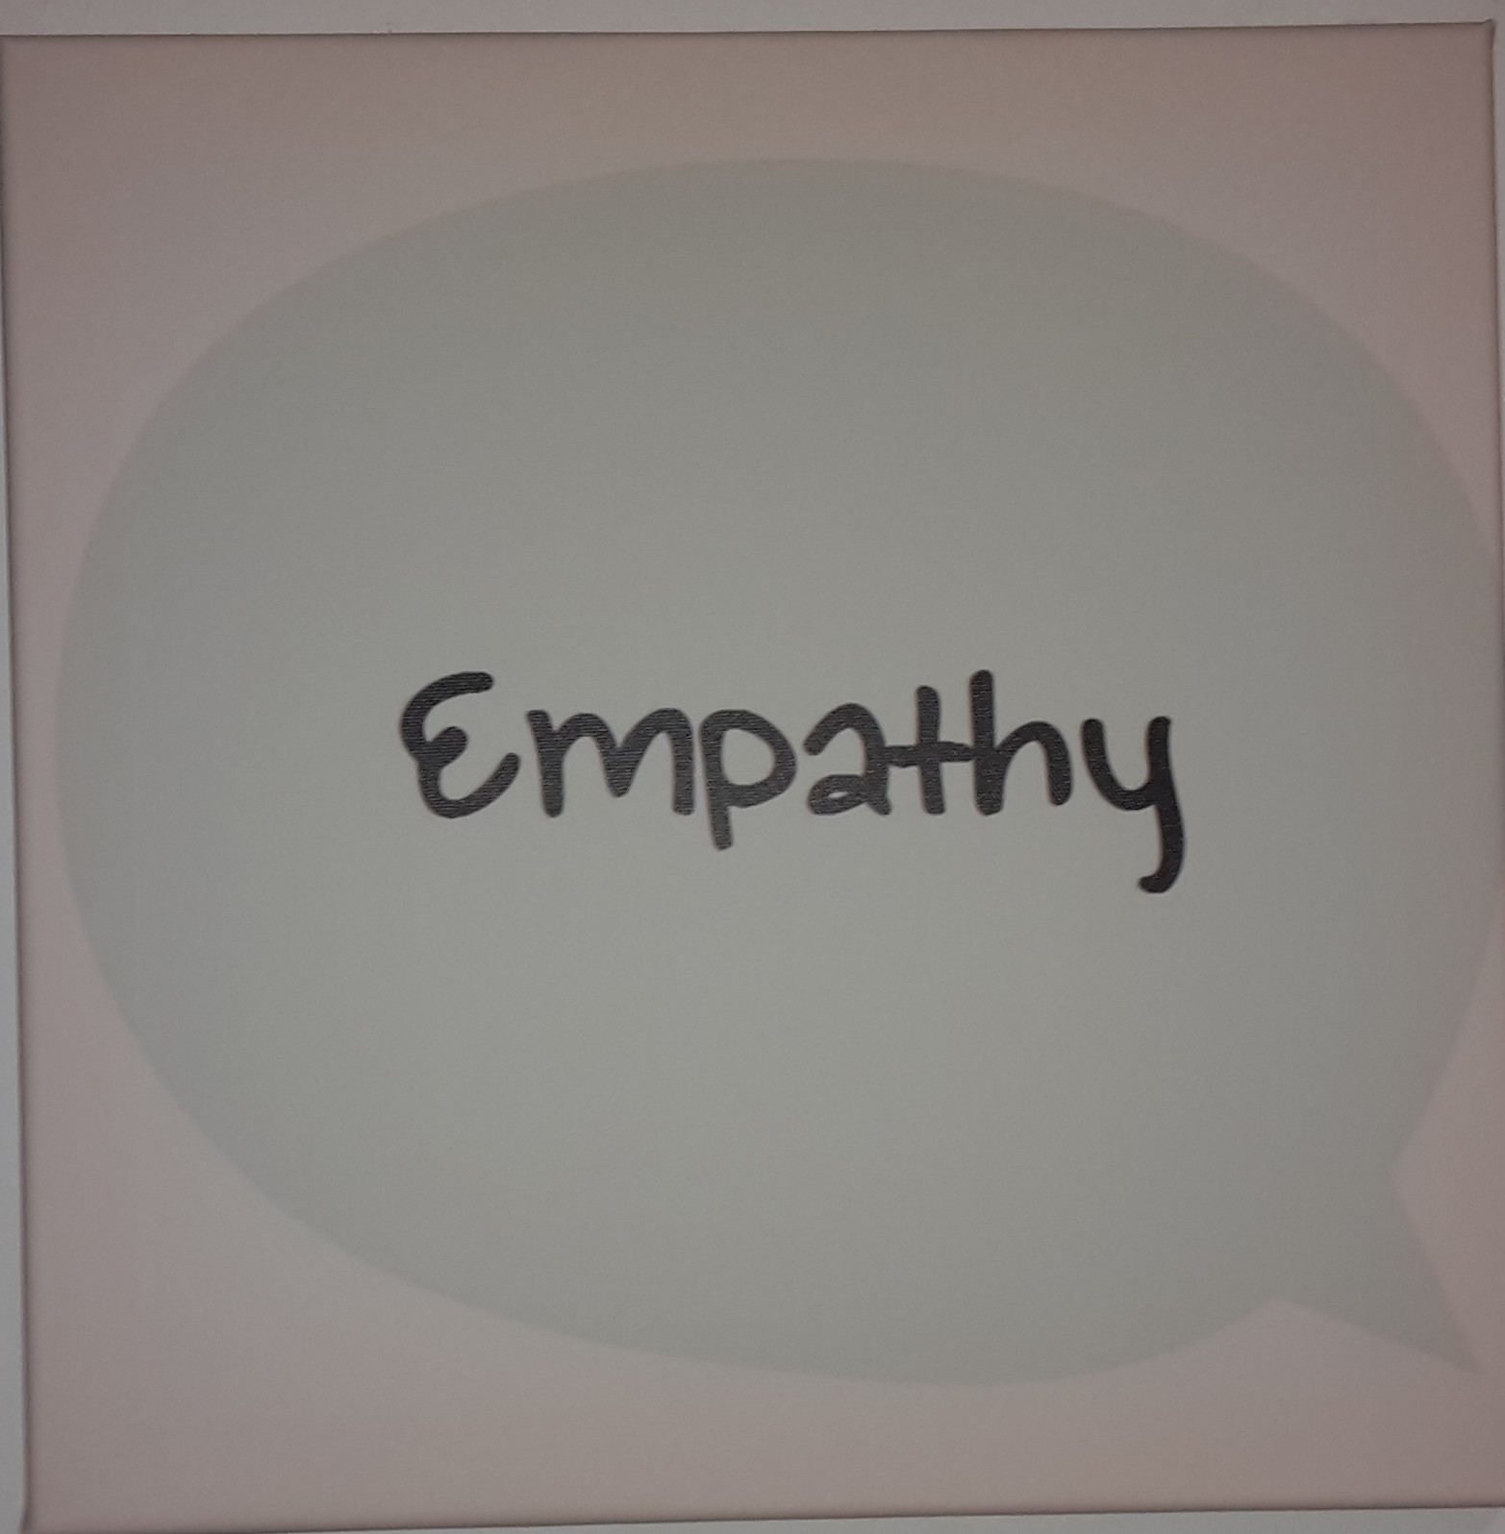

Richmond Fellowship
Wisbech March Godmanchester Cambridge

Clare Pecheur
Anne Wigglesworth
Lois Sidney
May 2016

Index:
Summary of Five Values………………………………………………. Page 1
Summary of service…………………………………………………….. Page 1
Brief introduction………………………………………………………… Page 1
Report Mental health support: ….................................... Page 2
Report Retain Regain: …………………………………………………. Page 5
Conclusion…………………………………………………………………… Page 8

Star Rating

The SUN Network 5 values peer assessors have awarded The Richmond Fellowship 4 stars for their work in the field of mental health support and recovery.
Summary of five Values:
The SUN Network’s Five Values are the result of a project whereby The SUN asked as many people as they were able, what five values they would like to see delivered by mental health services across Cambridgeshire. After consultation, the following five values were chosen:
- Empathy
- Honesty
- Inclusion
- Personalisation
- Working Together
A focus group then worked together on what these five values mean. Once that was decided, the focus group worked together on creating a way to assess services against the 5 values.
Two members of the focus group then co-delivered training for peer assessors.
The first assessment was of Richmond Fellowship service in May 2016.

Summary of Richmond Fellowship
The Richmond Fellowship is a countywide third sector mental health organisation with two strands. It offers mental health support focusing on recovery and also a service to help people who have experienced mental health challenges to find or stay in employment. (Retain, Regain service)
Support is offered in many ways to include one to one support, community based support, peer support, training, advice and guidance, signposting, support finding volunteer positions, writing C.V’s, applying for jobs, activities and groups.

Brief Introduction:
For the purpose of this report, Lois Sidney and Anne Wigglesworth from the SUN Network and Clare Pecheur who has previously accessed mental health services (not Richmond Fellowship) visited the RF offices at March, Wisbech and Godmanchester and spoke with staff and clients of the service. Policies and anonymised case notes were also reviewed. The report will be delivered in two parts to denote the two strands of service.
The Five Values Report - Mental Health Support Service:
The Richmond Fellowship delivers mental health support from two locations across the Fenlands, March and Wisbech and the same staffing group covers both areas on alternate days of the week to ensure access is equitable.
The SUN Network five values team visited both sites to speak with staff and clients and assess the service against the five values.
The staff at the service were extremely supportive of our visit and well prepared in terms of structuring the day and providing an appropriate room that allowed for privacy and no interruption, with access to staff and service users and a folder of paperwork ready for us to review. The paperwork included anonymised client files, policies, procedures and mission statements. Also included was a method of charting clients progress known as the Recovery Star.
We spoke with approximately 12 clients and were able to formally interview 5, and spoke with all staff on duty and were able to formally interview 3. The questions designed by the SUN Network focus group covered a broad range to ensure coverage of the five values.
Methods and Procedures:
RF have staff that are aware of the values expected of them by both managers and clients. This is evident by their knowledge of the values and standards that they are working to via the mission statements and the respect and integrity shown.
The interviewers felt that the staff were very genuine and sincere in their responses to the questions that were aimed to ensure that they had a clear grasp of clients’ needs and expectations. They were able for example to structure realistic expectations of those who expected a counselling service and signpost to other relevant services.
There was also a very definite personalisation of the service from staff perspective and a very non-judgemental and accepting attitude.
There was a clear complaints/comments policy available for clients and many opportunities to feedback to the staff about the service. All other policies were available for clients to access either as a hard copy at the office, or via the computer.
Care plans/ Case notes:
Staff were asked questions around the protocol of care plans and the following was evident.
- Care plans were completed with the client and there was an invitation to include family members, whilst bearing in mind dependant and abusive relationships.
- Care plans were reviewed on a regular basis and updated or changed as the client required.
- There was a continuity of staff with coverage for absences and this ensured no adverse impact on clients.
- Care plans were personalised and written in the presence of clients.
- Clients were offered a copy of their care plans or case notes.
- Advocacy was discussed with service users.
- Confidentiality was maintained at all times with appropriate storage and computer protocol.
Meeting the needs of service users and the five values:
All of the staff were able to give an example of when they had supported a client through an emotional experience and the support was delivered in a very personalised and empathic way. They obtained client understanding from the very first meeting as to how they could work together and offered a holistic approach to recovery. They signposted to other services and activities within the community, and each member of staff rated the service 4/4 in each of the five values. There are volunteer and training opportunities for clients to engage in and lived experience of mental health challenges is encouraged within staff applications. RF work in a very transparent way with regards to what support is on offer and timescales, and have systems in place to ensure the consistency of the service is delivered in a personalised way.
Environment and staff support:
All the staff felt that the physical environment was appropriate for delivery of service offering confidentiality and a welcoming feeling. Staff acknowledged that it can be challenging work and stated that they have regular supervision with a manager and that they feel supported, are able to take ‘time out’ have a free counselling service and support phone line available to them, and can share with the team if there is a need for extra support.

Service User Feedback:
The clients interviewed were asked a broad range of questions designed to explore their thoughts and feelings about the RF service.
We spoke to 4 male and 1 female clients, ages ranging from 31-55 years.
3 accessing Wisbech RF and 2 accessing March RF.
Length of access ranged from 1 to 15 years.
Ways in that the service met the individual needs were as follows:
- It gives purpose/is meaningful
- It is confidential/consistent
- Combats isolation/ It isn’t just me
- Helps me grow as a person/gives confidence
- Staff are respectful and compassionate
- Do not feel judged
- Work at my pace
- Staff explain things clearly and concisely
- Staff are quick to respond
- The contact is regular
- Staff make the time to get to personally know the client and therefore can tell when things are not great
All 5 clients were aware of their case notes/care plan and had input into it and 4 of the 5 could recall the last review. They all felt it was recovery focused and the star graph was helpful for progress monitoring.
All 5 were aware of policies and procedures and where to access them.
All 5 felt that the service was confidential, respectful and compassionate and that the staff showed great empathy. They felt staff were appropriately trained and qualified for the job and that staff signposted to other services including advocacy. 3 people had been supported through a crisis by RF staff which included regular phone contact between appointments and a hospital inpatient visit. These 3 people felt well supported in a time of crisis.
All 5 were aware of engagement and volunteering opportunities.
Other comments given were as follows:
- I am happy with the service
- Staff are always available if I need them
- I want to give something back to RF for all their help
- RF saved my life
- I can be myself
- Cannot stress enough how good it is coming here
- A massive help

The Five values report: Retain Regain service:
For this strand of the service delivery, we visited Godmanchester and were able to speak with approximately 7 staff and formally interview 2 and formally interview 3 clients.
Methods and Procedures:
As with the previous experience of RF, the staff here were very knowledgeable with regards to the services mission statement and values, policies and procedures.
The staff were also very empathic and compassionate when discussing their work with clients and deliver a personalised service with realistic outlooks working at the clients pace.
Again a clear complaints/comments procedure and all policies available in hard copy and on computer, with copies of all salient policies in the client’s files.
Care plans/Case notes:
The staff were very supportive of clients bringing someone to the initial meeting if it meant that they were more likely to access the service, and also encouraged a level of independence. Advocacy was explained and a very clear expectation of how the service can help was given. Signposting to other services and volunteer opportunities was also offered. Goals were set to be realistic and monitor progress. The client was at the heart of the process and involved continuously. Case notes were reviewed regularly and with every contact with the client. Clients were offered a copy of the case notes.
All staff offered a consistent service with good coverage if staff were unavailable. Case notes were stored confidentially.
Meeting the needs of service users and the five values:
Both members of staff were able to offer an example of when they had supported a client through an emotional time, and both examples showed a personalised approach delivered with genuine concern and empathy.
They reported being very open and honest with clients about expectations of the service and working at the service users pace. They helped the clients to maintain realistic achievable goals.
Both members of staff had a sound working knowledge of all the RF policies, including the response times to client contact.
The staff worked in a very recovery focused way.
The service promotes engagement and involvement opportunities and encourages clients to become involved in a more strategic level, having their say up to board level.
Both members of staff rated RF 4/4 on all the five values.
Environment and staff support:
The staff were aware that one of their offices could make improvements to become more welcoming and these improvements were underway.
They were aware of the restrictions due to funding and were frustrated that they couldn’t offer a service over a wider locality and would like to have been able to be more involved in the local community, but are working on community networking.
Both members of staff felt very supported and felt RF offered a good training programme.
Service Users feedback:
We spoke with 3 clients, 2 of which were male, ranging in age from 31-65, and accessing the service between 4 and 9 months.
Ways in which the service met their individual needs are as follows:
- Good advice/constructive criticism
- A clear pathway to follow
- Worked at my pace
- Offered understanding
- Available when I needed them
- Regular contact and appropriate support
All 3 clients felt like they set their own goals for their care plan and were involved in the entire process with ongoing reviews.
All 3 were aware of the policies and procedures and were happy to ask to see them.
All 3 were very definite about feeling that they were treated with respect and compassion with one client informing us of an experience that would usually have been a struggle for them but with the understanding, support and empathy of the staff, was able to manage.
They felt the approach was collaborative and they were working together, and were always able to contact someone when they needed to. They found the staff respectful and approachable and good at listening.
One client mentioned the receptionist in particular who always greeted them by name with a warm and welcoming smile and offered a cup of tea. This took away any anxiety of walking through the door each time.
They felt staff were appropriately trained and qualified for the job and were aware of opportunities open to clients to be involved.
Other comments were as follows:
- Tissues, and understanding were offered
- Really grateful to really nice people
- Some members of staff have no reason to know me but still acknowledge me by name
- I don’t know where I would be without the service
- The staff really care
- Real warmth of people
- Trust, confidence, positivity
- Acceptance
- Never felt judged, can just be myself and that’s ok
- Very safe
Conclusion:
The conclusion is a personal overview written by Clare Pecheur:
The RF offers a service that is respected, trusted and valued by all who use the service. There was a strong sense of teamwork and ethics shown by staff. The five values were clearly demonstrated by staff who answered our questions without hesitation and with knowledge of how to show working together, empathy, honesty, personalisation and inclusion with all they work with.
The clients were full of praise and enthusiasm around the care and support that they receive from any member of staff that they come into contact with. It was felt that if there was an area that they didn’t know about, they felt comfortable enough to ask for any information that they may need. Each client spoke very highly about the staff and the support they receive on any visit.
After listening to the views of the service from clients and staff over the duration of the time spent with RF, I felt the standards were not only of an acceptable level but actually of an exceptionally high level. The enthusiasm that was shown by the staff in each of the areas visited was matched by the respect and interaction of the clients each time they visited for a session or a workshop. I observed that there was never an occasion where the member of staff was at a loss as to how to answer a question. If anything was needed, it was requested and available promptly.
There was a high level of teamwork which showed in the manner in which the team spoke and interacted with each other. When I was in the office with staff, the phones were answered promptly, admin was being worked upon so as to keep up to speed with deadlines and to ensure that records and notes were made immediately. While reviewing anonymised files that had been provided by staff, the dates all tallied and the work was relevant to the person’s needs. Also contained within a file that was prepared for us were templates of the letters that are used with clients, for example, appointment letters and a clear outline of the referral, assessment and allocation process. Other sections included copies of leaflets that are currently available. A printout of the RF strategy and mission statement was included and versions of policies, all of which would be available on request. There was a transparency within all aspects of RF which is important for the clients to be able to build a rapport with their support worker so as to achieve a respect so that they can feel confident in being able to open up and discuss what they need to with no feelings of judgement or as though they couldn’t or shouldn’t say what they need to.
The star rating that was on the five values questionnaires is found next to the questions that were asked to members of staff and to clients. In some cases, the questions may have warranted a lower grade star, an example of this would be if the question asked was not relevant to the client or member of staff and in this case it would be stated on the questionnaire that it is not relevant.
The space at the end of the questionnaire was larger to try and accommodate any views about the service that the client or staff member felt that they wanted to express. This is an important aspect of the questionnaire as any area that was not covered by the questions could be acknowledged in either a negative or positive aspect.
The overall impression I came away with is that RF is doing a very important job in a very effective way. The staff are all competent, willing and sincere in their approach and in their manner with clients and other team members equally. The clients are happy with the environment they are seen in and the staff that they see. They all feel respected and like they are treated with consideration and care, very important elements in an individual’s personal journey.
Star rating:
I would grade the RF with 4 stars as I feel that the way in which they work is valid and shows a true level of empathy and commitment to helping others. I thought all five values had been included. I feel that they are having a positive impact on everyone who accesses the services of RF.

